Blinkit Analysis
- See all the data imported:
SELECT * FROM blinkit;
- DATA CLEANING:
Cleaning the Item_Fat_Content field ensures data consistency and accuracy in analysis. The presence of multiple variations of the same category (e.g., LF, low fat vs. Low Fat) can cause issues in reporting, aggregations, and filtering. By standardizing these values, we improve data quality, making it easier to generate insights and maintain uniformity in our datasets.
UPDATE blinkit SET Item_Fat_Content = 'Low Fat'
WHERE Item_Fat_Content IN ('LF', 'low fat');

UPDATE blinkit SET Item_Fat_Content = 'Regular'
WHERE Item_Fat_Content = 'reg';
After executing this query check the data has been cleaned or not
SELECT DISTINCT Item_Fat_Content FROM blinkit;

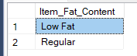

A. KPI’s
1. TOTAL SALES:
SELECT ROUND(SUM(Item_Outlet_Sales) / 1000000.0, 2) AS total_sales_millions
FROM blinkit;
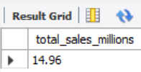
2. AVERAGE SALES
SELECT CAST(AVG(Item_Outlet_Sales) AS DECIMAL(10,2)) AS Avg_Sales
FROM blinkit;
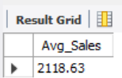
3. NUMBER OF ITEM TYPES IN EACH GROUP
SELECT COUNT(*) as total_items
FROM blinkit;
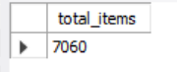
4. TOTAL OUTLET TYPE OF EACH CATEGORY
SELECT Outlet_Type
COUNT(Outlet_Type) as total_outlet_type
FROM blinkit
GROUP BY Outlet_Type;
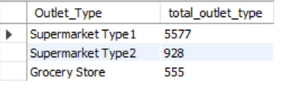

5. TOTAL REVENUE OF EACH OUTLET
SELECT Outlet_Type,
ROUND(SUM(Item_Outlet_Sales),2) as outlet_sales
from blinkit
GROUP BY Outlet_Type;
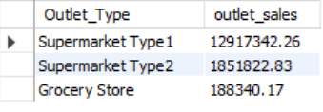

B. Total Sales by Fat Content:
SELECT Item_Fat_Content,
ROUND(SUM(Item_Outlet_Sales),2) As total_sales,
COUNT(*) as item_count
FROM blinkit
GROUP BY Item_Fat_Content;
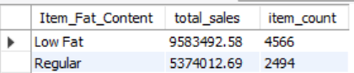

C. Total Sales by Item Type
SELECT Item_Type, CAST(SUM(Item_Outlet_Sales) AS DECIMAL(10,2)) AS Total_Sales
FROM blinkit
GROUP BY Item_Type
ORDER BY Total_Sales DESC
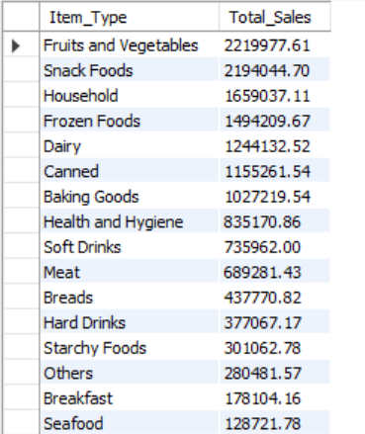

D. Item types with highest revenue
SELECT Item_Type,
ROUND(SUM(Item_Outlet_Sales),2) as total_sales,
COUNT(*) as item_count
FROM blinkit
GROUP BY Item_Type
ORDER BY total_sales DESC;
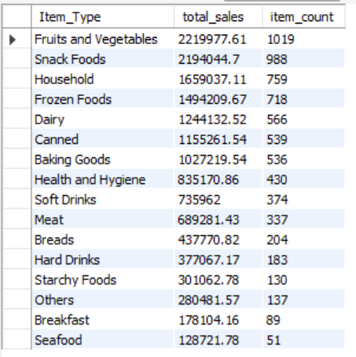

E. Sales performance by Outlet Size
SELECT
Outlet_Size,
CAST(SUM(Item_Outlet_Sales) AS DECIMAL(10,2)) AS total_sales,
COUNT(*) AS total_items,
CAST(AVG(Item_Outlet_Sales) AS DECIMAL(10,2)) AS avg_sales_per_item
FROM blinkit
WHERE Outlet_Size IS NOT NULL
AND TRIM(Outlet_Size) != ''
GROUP BY Outlet_Size
ORDER BY total_sales DESC;
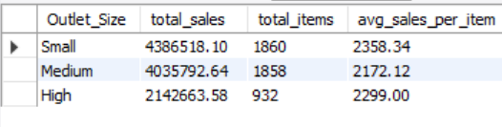

F. Location tier that performs best
SELECT Outlet_Location_Type,
ROUND(SUM(Item_Outlet_Sales),2) as total_sales
FROM blinkit
GROUP BY Outlet_Location_Type
ORDER BY total_sales DESC;
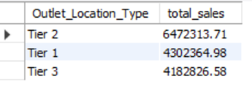

G. Sales by Outlet type
SELECT Outlet_Type,
ROUND(SUM(Item_Outlet_Sales),2) as total_sales,
COUNT(*) as item_count,
ROUND(AVG(Item_Outlet_Sales),2) as avg_sales
FROM blinkit
GROUP BY Outlet_Type
ORDER BY total_sales DESC;
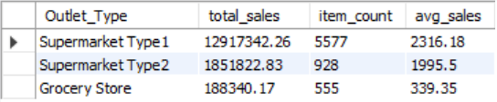

H. Highest-selling items by MRP range
SELECT
CASE
WHEN Item_MRP < 50 THEN 'Budget (Under 50)'
WHEN Item_MRP BETWEEN 50 AND 100 THEN 'Mid (50-100)'
WHEN Item_MRP BETWEEN 100 AND 200 THEN 'Premimum (100-200)'
ELSE 'Luxury (200+)'
END AS price_range,
COUNT(*) as item_count,
ROUND(SUM(Item_Outlet_Sales),2) as total_sales
FROM blinkit
GROUP BY price_range
ORDER BY total_sales DESC;n
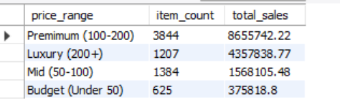

I. Best performing outlet type + location combo
SELECT Outlet_Type, Outlet_Location_Type,
ROUND(SUM(Item_Outlet_Sales),2) as total_sales
FROM blinkit
GROUP BY Outlet_Type, Outlet_Location_Type
ORDER BY total_sales DESC
LIMIT 10;
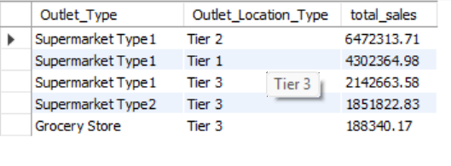

J. Percentage of Sales by Outlet Size
SELECT Outlet_Size,
ROUND(SUM(Item_Outlet_Sales),2) as total_sales,
ROUND(SUM(Item_Outlet_Sales) * 100.0 / SUM(SUM(Item_Outlet_Sales)) OVER(),2) as sales_percentage
FROM blinkit
GROUP BY Outlet_Size
ORDER BY total_sales DESC;

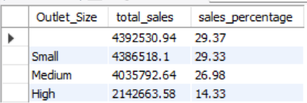

K. All Metrics by outlet type
SELECT Outlet_Type,
ROUND(SUM(Item_Outlet_Sales),2) as total_sales,
ROUND(AVG(Item_Outlet_Sales),2) as avg_sales,
COUNT(*) as no_of_items,
ROUND(AVG(Item_Visibility),2) as item_visibility
FROM blinkit
GROUP BY Outlet_Type
ORDER BY total_sales DESC;
